
phgy312
lecture #: | date: | professor:
10 | January 24, 2007 | Dr. Shrier
11 | January 26, 2007 | Dr. Magder
announcements:
- Come join PULS for an all you can drink event at Veranda! Tuesday Feb. 6 we’ll be watching the hockey game while having some beers for only $5!!!
- Good luck on the exam!

Edited By: Aradhana Persad and Lisa-Marie Perrella
Do Not Redistribute.
set #4
PHGY 312 – Lecture 10 January 24, 2007
Writer: Sameer Apte Dr. Shrier

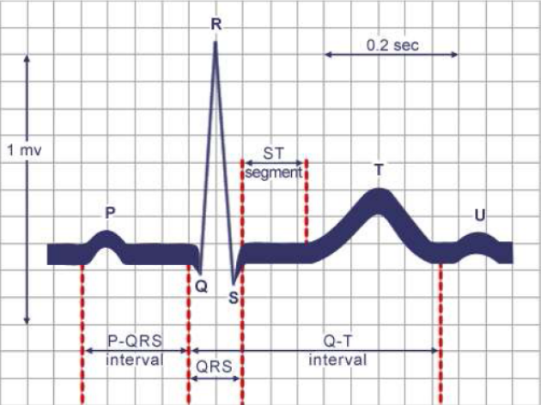
I. The Electrocardiogram

P-wave
- The P-wave represents the propagation of an electrical impulse through the atrium. The excitation of the SA node is not detectable because it is such a small area.

PR Interval
- It is measured from the beginning of the P-wave to the beginning of the QRS complex.
- It reflects the electrical excitation of the atria and the AV node. Excitation of the AV node occurs about half way through the P wave, but is also not detectable.
.
Under pathological conditions:
- If there is a delay in conduction through the AV node, the PR interval gets longer. This is called 1st degree AV block.
- When some of the impulses through the AV node are blocked, it becomes a 2nd degree AV block. In this case, not all P-waves are followed by a QRS wave.
- When no impulses propagate through the AV node, we have 3rd degree AV block. This is a complete dissociation between the P wave and the QRS complex. It is also known as Heart block.

QRS Complex
- This complex represents the depolarization of the ventricles.
- It reflects how fast the impulse is propagating from the AV node, through the bundle branches and the walls of the ventricle. This propagation usually occurs very quickly, so the QRS complex has a relatively short duration time (40 - 60 ms).

Under pathological conditions:
- If there is a problem with conduction, particularly down the bundle branches, the QRS complex can become broader, representing a slower propagation.
- Chagas disease and Lyme disease are both infectious diseases that lead to the broadening of the QRS complex.
- A widening of the QRS complex can also occur if the electrical signal is originating from somewhere outside of our rapid conduction system.
- For example, if the impulse is not being conducted through the bundle branches, we are unable to take advantage of their rapid conduction velocity. As a result, it takes longer for the impulse to propagate throughout the ventricles via its alternative pathway.
- The impulse enters through an alternative route in the case of an abnormal re-entrant rhythm (to be discussed later).

ST Segment
- This segment is measured form the end of the QRS complex to the beginning of the T wave. There is very little voltage change seen because the ventricles have already been depolarized. This is the plateau of the action potential, where the voltage throughout the ventricles is relatively the same.

Under pathological conditions:
- Having a ST segment that is not flat indicates a pathological problem, mainly pertaining to the ventricular walls. This can be caused by an injury current.
- Other conditions that will affect the ST segment include a myocardial infarction and pericarditis.

QT Interval and T-wave
- The T-wave represents the repolarization of the ventricles. Note that repolarization of the atria is not seen because it occurs during the QRS complex.
- The QT interval is the time from the beginning of the QRS complex to the end of the T wave. Normally, this interval is 330-430 msec.

Under pathological conditions:
- Elongation of the QT interval can occur for various reasons.
- If a few of your sodium channels do not inactivate, they will continue to provide an inward current. This will prolong the action potential duration, resulting in a longer QT interval.
- This can be caused by the SCN5A mutation of your sodium gene.
- Mutations in the delayed rectifier channels, I_{Kr} and I_{Ks} can also prolong the QT interval.
- QT elongation is a major problem since it makes you prone to sudden death.

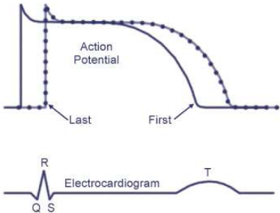
The ECG and a Ventricular Action Potential
- The beginning of the QRS complex represents the activation of the first cell in the ventricles, and the end of the QRS complex represents the last cell to be activated.
- Similarly, the beginning of the T wave represents the repolarization of the first cell in the ventricles, and the end of the T wave represents the last cell to be repolarized.
- Together, the QRS complex and the T wave represent the spread of the impulse through all cells in the ventricles.
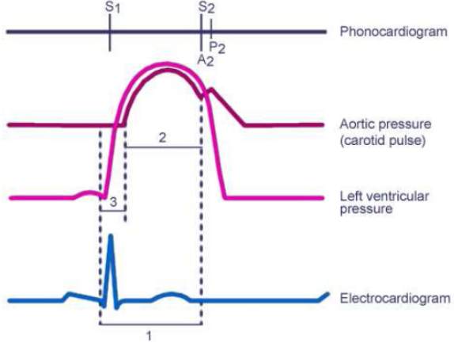
Electrical versus Mechanical Activity
- The QRS complex precedes the contraction of the ventricles. It finishes very quickly, while contraction of the ventricles continues for much longer. Therefore, the QRS complex triggers muscle contraction, but there is a time delay before contraction is seen.
- Also, repolarization of the ventricles (T-wave) precedes relaxation of the ventricles.

Take Home Message: Electrical excitation and muscle activity occur over different time frames.

The ECG as a Voltmeter
- Consider a dipole with arbitrarily marked positive and negative charges. Recall that dipoles can move.
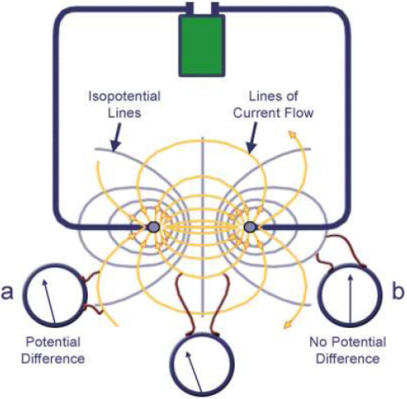
- The site of depolarization of the heart can be thought of as a dipole. One side of the dipole is the activated part of the heart, and the other side is the inactivated area.
- As the action potential propagates down the tissue, the dipole moves.
- The size of the signal you get depends on how much tissue is involved. The bigger the signal, the larger the amount of dipolar tissue.
- The largest possible signal we can obtain corresponds to when half the heart is being excited and the other half is unexcited.
- The AV node is only a couple millimetres in diameter
- It has only a small amount of dipolar tissue (when there is an impulse), so the field created by the AV node will not be very large.
- Therefore, we don’t see that much of a signal from the AV node on the ECG.

- The ECG is not a static image. It changes dynamically with time. The size of the impulse that is recorded will depend upon:
- When you are looking at the ECG
- How you are looking at the ECG

Why is this?
- The yellow lines are the current flow through the dipole (the lines with arrows). Orthogonal to the lines of current, are the lines of identical voltage, called isopotential lines (the lines with no arrows).
- If you put the leads of a voltmeter on the same isopotential line, you don’t record a signal because there is no potential difference.
- If you put the leads on different isopotential lines, you will record a voltage difference.
- If you place your leads perpendicular to the direction that the impulse (dipole) is traveling, you will see a very small signal because the isopotential lines are only crossing you and you don’t see a large amount of the signal at once. When you put the leads across the dipole (parallel), you see the largest signal.

Note: This concept can be thought of in terms of an arrow coming at you. As you watch an arrow approach you, it is perpendicular to you and all you see is the tip of the arrow. In other words, you don’t see a large area of the arrow, just like you don’t see a large amount of a perpendicular dipole. When the arrow is moving parallel to you, you can see the whole arrow and therefore a much larger area of it. So with a parallel dipole, you are seeing more of it and thus, see a much larger signal.

- During an ECG, the leads are fixed and the dipoles are always changing directions.
- So when the dipole is perpendicular to the leads, you get a small signal, and when it’s parallel to the leads you record a large signal.

II. The Twelve Lead ECG

- A 12-lead ECG is used in standard clinical situations.
- The first 6 leads are surface leads that record from the arms and legs. They are divided into two categories:
- 3 standard limb leads
- 3 augmented limb leads.
- The word ‘lead’ does not describe the physical cord that is attached to the body, but rather describes a dipole between two leads.
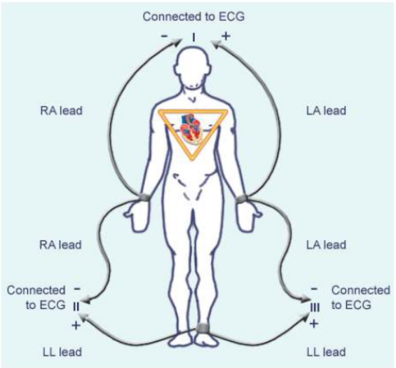
- To record from all 6 leads, we only have to attach 5 physical wires: right arm (RA), left arm (LA), left leg (LL), right leg (RL, ground), and an exploring wire.
- The ECG has a positive and negative terminal. Connecting the different parts of the body to these terminals produces the dipoles that give us our leads.
Fig. 1

The 3 Standard Limb Leads (Fig 1)
- The leads are arranged such that there is a dipole between them:
- Lead I: the left arm (+) and right arm (-)
- Lead II: the right arm (-) and left leg (+)
- Lead III: the left arm (-) and left leg (+)
- In this format each wire is referenced to another wire.
- By approximating an equilateral triangle with the heart in the center (Einthoven’s triangle) and by using Kirchoff’s Law of Voltages, we know that the sum of Leads I, II and III is equal to zero.
- This creates a reference.

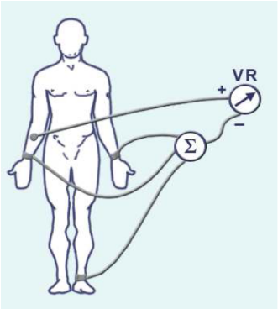
The 3 Augmented Leads (Fig 2)
- Using Einthoven’s triangle, we can join the wires from the RA, LA, and LL, and connect them to the negative terminal. This is called Wilson’s Central Terminal.
- Using the exploring wire (+), we can probe the RA, LA and LL to get a voltage difference. Probing:
- The RA gives us the lead ‘aVR’ (augmented voltage right).
- The LA gives us the lead ‘aVL’ (augmented voltage left).
- The LL gives us the lead ‘aVF’ (augmented voltage foot).
Fig. 2
- Attaching the leads this way was originally done because the signal size recorded is augmented 1.5 times the signal size recorded from the 3 standard limb leads.

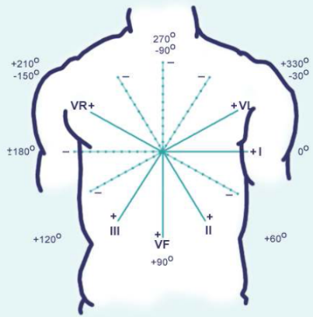
- These six dipole leads (lead I, lead II, lead III, aVR, aVL, and aVF) are the first 6 leads of the ECG. They record in the frontal plane of the body (a 2D plane).

Coordinate System for Measurement of Axis
  - Each lead gives you a different perspective on the heart, and therefore a better understanding of the electrophysiology of the heart (Think of viewing a car from 6 different angles).
- By measuring the ECG at the peak of the QRS complex, and doing some vector analysis, you can calculate the ‘mean electrical axis of the heart’. This is defined as the direction at which the impulse is conducted at the peak of the QRS complex.
- This occurs most often in the direction of Lead II. If you are recording from Lead II, you record the biggest signal because the impulse is traveling parallel this lead. If you record from the ‘aVL’ lead, you get the smallest signal, because the impulse is traveling perpendicular to the aVL lead.
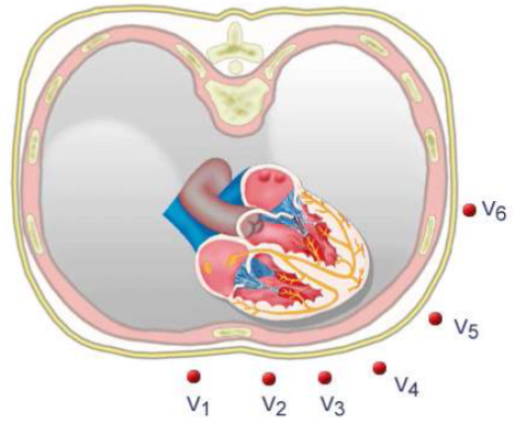
Chest Leads
- Instead of placing the electrodes on our limbs, we now place them on our chest at six very well define points: V1, V2, V3, V4, V5, and V6.
- Collectively, these leads are called the Precordial leads.
- Using the exploring lead, we can probe around the trunk of the chest.
- This gives you 3-D dimensional information, from the chest around to the back.

- In total we have 12 leads: Leads I-III, aVR, aVL, aVF, and V1-V6.
- Using all 12 leads we get 12 different perspectives of the electrophysiology of the hearts, which can tell us information pertaining to our next topic.

III. Cardiac Arrhythmias

- A heart rate above 90 bpm is called tachycardia. A heart rate below 60 bpm is called bradycardia.
- Some well trained athletes have bradycardia due to their cardiovascular conditioning. So having a slow heart rate by itself doesn’t indicate an illness.
- An impulse propagates from the SA node, the dominant pacemaker.
- It is the dominant pacemaker because it pulses at the fastest rate.
- By having a faster rate it is also a natural suppressor of other pacemakers in the heart.
  - If you stimulate a pacemaker at a faster rate than normal and then stop the stimulation, the pacemaker will pulse at a rate slower than its normal rate. Eventually, it will increase back up to its original rate, start to beat normally. This allows the SA node to take over as the pacemaker.
  - Stimulation is called overdriving a pacemaker. The suppression resulting from this is called overdrive suppression. This suppression ensures that other pacemakers don’t compete with the SA node.

An Abnormal ECG with AV Block (Diagram Below)
- Initially there is a normal ECG with P-waves coupled with QRS complexes.
- Then we see a P-wave with no QRS complex following it. This indicates that there is no electrical impulse travelling to the ventricles.
- Further along the ECG, there is a QRS complex seemingly out of nowhere. This complex came as a result of the AV pacemaker.
- This is followed by a P-wave, but a QRS complex is missing again. These complexes are called Escape beats.

What happened?
- For a short time the AV node took over, when the SA node failed or was blocked.
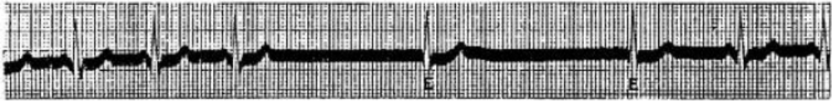
  - These other pacemakers are called subsidiary pacemakers. If you have a complete heart block, then you need a subsidiary pacemaker so that you can have an impulse propagated in the ventricles.
- Sometimes other parts of the heart can take over abnormally.
- Heart wall injury or purkinje activation due to drug use, can create another pacemaker site. A site like this is called an ectopic focus.
- The condition sick sinus syndrome occurs when where the SA node doesn’t function well. The SA node is no longer producing regular impulses. When this occurs the person will pass out, or atrial fibrillation will occur. This problem can be fixed with an artificial pacemaker.

IV. Mechanisms Causing Abnormal Rhythms
- There are different mechanisms through which abnormal rhythms can develop:
- Mechanism One: The SA node doesn’t function correctly. (As seen in the previous example)
- Mechanism Two: An ectopic pacemaker is created.
- Mechanism Three: After depolarization.
  - There are two types of after depolarizations: delayed after depolarizations and early after depolarizations.
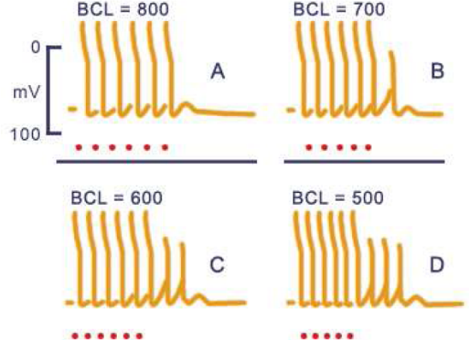
Delayed After Depolarizations
- Consider the figure to the right. The small (red) dots represent stimulated impulses. These stimulated APs appear larger due to stimulus artifacts.
Note: BCL is the interval of time between two APs

- After potentials are seen at the end of our stimulated impulses. These are the small rises in voltage seen between two stimulated impulses.
- An after potential, if large enough, can stimulate an action potential.
- As we increase the frequency of the stimulus, the size of the after potential increases, along with the size of the action potential.
- Ultimately, at the end of a high frequency burst you can get a sustained action potential.
- Afterpotentials occurring after repolarization are called ‘delayed after depolarizations’ (DAD)
- Normally, after potentials do not occur in our hearts, but they can be present if the force of the heart is increase, or if certain conditions lower potassium levels.

What causes this?
- There exists a channel in the heart which specifically contributes to this active depolarization.
- It is triggered by a rise of intracellular calcium. If you have digitalis and low potassium you tend to have a rise in calcium, and this can cause these after potentials by activating these channels.
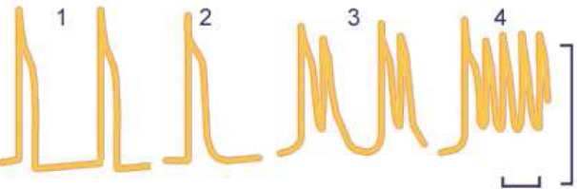
- The current going through these channels is a sodium current not a calcium current. Note that this is a specific and separate current (from the ones that we have discussed).

Early After Depolarizations
- A different situation occurs when the after potentials occur during repolarization. These are called ‘early after depolarizations’ (EAD)
- These occur when the duration of the action potential is prolonged. It can occur for one beat, or continue for several beats and trigger a series of spontaneous action potentials.
What causes this?
- The mechanism that underlies this is thought to be associated with the reactivation of calcium channels during repolarization.
- The broadening of the action potential can be associated with the Long QT syndrome.
- The idea is that if you get prolongation of a ventricular action potential, especially if this does not occur in every part of the ventricle, you set up the circumstances for getting EAD. This can lead to much more complicated arrhythmias.
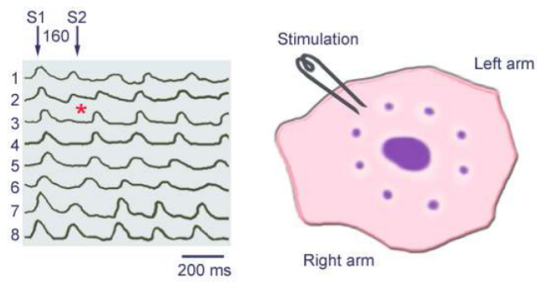
Re-entry
- A fourth mechanism is the idea of re-entry.
- A former McGill professor noticed that if he cut a section of a turtle heart into a ring, and touched it with a probe he could generate a circular wave of contraction. If he then touched it again, he could stop it. This was called ‘Circus movement tachycardia’.
- The diagram (above) represents a stimulus being stimulated prematurely.
Note: The S2 arrow should actually be shifted over to the right. The dots on the ring should also be numbered.

- The stimulating electrode sits between recording sites 2 and 3 (purple dots).
- Originally when we stimulate (S1), the impulse can travel in both directions around the ring: 2, 1, 8, 7, 6… and 3,4,5,6…
  - This active impulse propagates around the ring until it runs into itself from the opposite direction. At this point it stops.
- While the impulse is propagating, a second impulse (S2) is introduced. This introduction occurs when part of the ring has recovered and the other part of the ring has not.
  - Going in the direction of 2, 3, 4… we see that the stimulus is blocked. Therefore, the stimulus goes around 2,1,8,7,6,5,4,3,2,1 repeatedly.
  - These circular impulses of reentry can go for a long period of time.
- This is what can happen in your heart.
  - Certain arrhythmias can occur in the vessels of your heart. If you have an area of block or unequal excitation, you can generate re-entry by using a premature stimulus.
  - This creates a site of very rapid stimulating waves, causing a paroxysmal tachycardia.

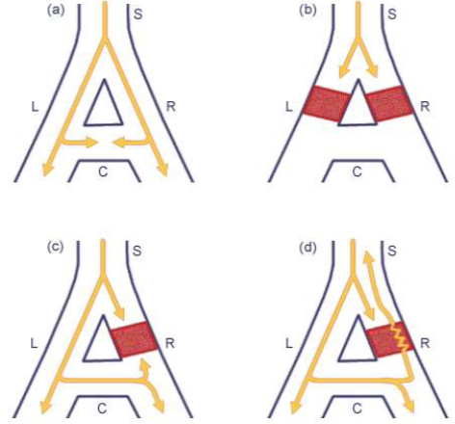
Micro Re-entry:

Note: This is called micro re-entry because it involves a very small area of tissue

- Fig A. Impulse travels down the two branches and collides cancelling each other out.
- Fig B. If both branches are blocked, there is no reentry.
- Fig C. If one branch is blocked, there still can’t be re-entry. The impulse will go around, but not penetrate.
- Fig D. If one branch is refractory (i.e. The AP duration is abnormally long) when the signal first travels down, it will be blocked. When the AP traveling down the other side reaches the block, it may not be in the refractory stage anymore. Therefore, the AP can transverse the block, causing reentry.
- There are thought to be two entrances into the AV node. There are some circumstances where an impulse can leave the AV node in the opposite direction and go back into the atrium.
- This can cause rapid tachycardia, and even atrial fibrillation.
- 10-12 years ago, a number of cardiologists tested the ablation of a part of the AV node using a catheter and radiation to treat reentry. In 90% of the cases they can get rid of this arrhythmia.

Macro Re-entry:
- Normally an impulse travels down through the SA node, AV node, Bundle of His, and septum ventricular wall. These impulses collide and annihilate each another.

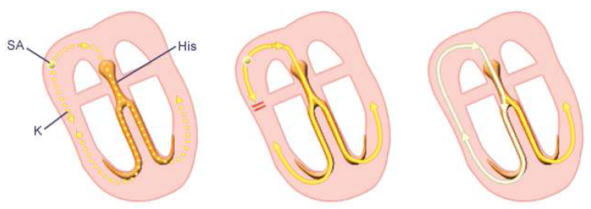
- The bundle of Kent is located in the ventricular wall. Normally, if the bundle of Kent collides with an impulse traveling down the normal pathway, it is not a problem because it does not allow the impulse to propagate through.
- But, if for some reason bundle of Kent gets blocked or the timing changes, the impulse can go through the bundle of Kent, up into the atrium and back through the AV node, to trigger another impulse.
- This condition is called wolf-Parkinson-white syndrome. The limiting factor is the rate of conduction through the AV node.
- In some cases, if the impulse is circulating in a direction where it doesn’t go through the AV node, but goes through the bundle of Kent, you can get changes in the width of the QRS complex.

- Re-entry doesn’t have to be a ring of tissue. It is possible to have re-entry in a ventricle that is not a ring.
- If heart cells are cultured at high density, they become very well coupled. This forms a pacemaker.
- If we start to uncouple them, the pacemaker slows down.
- If we uncouple them even further (gap junctions being unconnected) we get spiral waves, that will go around and around. These waves can start and stop by themselves.
- It’s almost like paroxysmal tachycardia.
- If we have heart disease, cells can become so uncoupled that they can become disorganized.
- In the atrium this is called atrial flutter.
- If the cells become more disorganized and there is no concrete contraction, you have atrial fibrillation. This is normally a manageable condition.
- If you get fibrillation in the ventricles however, you will die. The only way to fix it is to try and synchronize the electrical impulses of all the cells, causing them to beat in rhythm again.
- This is done by depolarizing all the cells at the same time, with a defibrillator.

PHGY 312 – Lecture 11 January 26, 2007
Writer: Jordana Remz Dr. Magder

Recall these Key Points:

Cardiac output (CO) determines blood pressure. The reverse is not true!
- Actual CO is determined by the interaction between the cardiac function (set of COs and preloads for given heart rate, contractility, and afterload) and circuit function (venous return for given stress volume, compliance, and resistance of vasculature)

Cardiovascular Regulation
Regulation is complex, but certain factors are considered more important than others.
Note: You do not have to memorize the slide with all of the regulatory factors!

I. Baroreceptor Reflex

- This is the major determinant of vascular tone and blood pressure (BP)
- Baroreceptors are cells that respond to stretch and distortion of their cell membrane.
- Your main baroreceptors located in the arterial walls of the carotid sinus. The carotid sinus is a bulge located at the bifurcation of the common carotid artery.
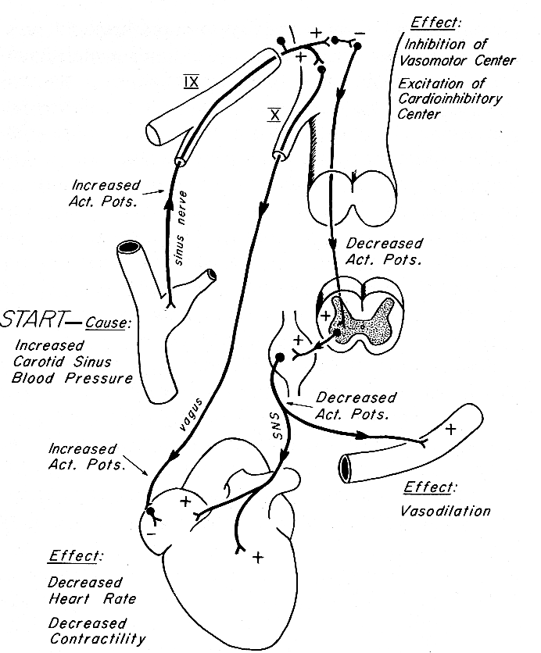
- Note that we also have baroreceptors in the aortic arch, but the carotid sinus dominates regulation.
Fig. 1

- If the carotid sinus pressure is increased (Fig. 1), the receptor is stretched and it sends a signal via the sinus nerve to the brain.
This results in:
- The increased stimulation of the vagus nerve. This reduces your heart rate (HR) and therefore decreases the CO and BP. There is little change in contractility since the vagus mainly innervates the atrium.
  - This is an example of the activation of an inhibitory pathway.
- The increased inhibition of the sympathetic nervous activity. This decreases its stimulatory effect on the heart and causes the removal of sympathetic tone (a minor effect at rest). It also causes a decrease in contractility and the vasodilation of vessels.
  - This is an example of the inhibition of an excitatory pathway.

- If the carotid sinus is occluded (ie. pressure decreased), there is a decrease in vagal stimulation and a decrease in the inhibition of sympathetic (ie. an increase in sympathetic stimulation).
- This results in the opposite effects: increased heart rate, contractility, peripheral constriction.

- This system is primarily used to reduce hypertension, since the baroreceptors are stretched and activated by the increased pressure.
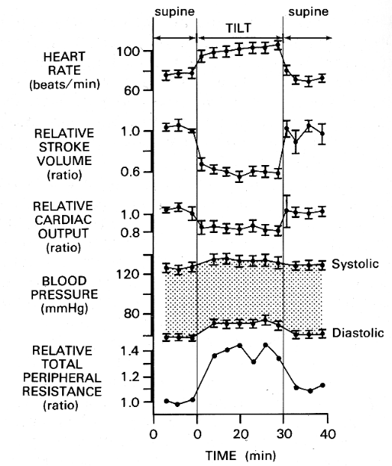
Fig. 2
Tilt Study (Fig. 2)
- The baroreceptor reflex is important in regulating against the effects of postural change. This is studied using a tilt test.
- A person is tilted upwards from the supine position
- The pressure transiently falls in the carotid sinus. This decreases the vagal stimulation and results in an increased HR.
- Initially, blood pools in the lower extremities, causing a decrease in stroke volume and cardiac output, but your increased HR compensates for this pooling.
- Your BP is maintained and actually rises slightly with the increase in peripheral resistance. This is due to the vasoconstriction of your vessels, caused by the decreased inhibition of the sympathetic system.
Note: The resistance is calculated from the CO and BP.

Problem with the Feedback Mechanism:
- We see a fall in SV and CO, but there is no fall in BP. The blood pressure actually overshoots. Why?
- Recall the lecture Dr. Madger gave last week about relative pressure.
- Your carotid sinus is located higher than your heart when you are upright. It registers a lower BP than the actual BP at the level of the heart. This results in the slight overcompensation seen. If you level it to your heart and measure the pressure at the carotid sinus, you will see that it is actually maintaining the correct BP.
- If the carotid baroreceptors were located at the level of heart, there would be no change seen in the BP.
- To maintain a constant pressure in the brain, having the main baroreceptor outside of the thorax and closer to the head is a beneficial design. If the baroreceptor was in the thorax, it would respond to the changes in pressure with each breath. This would cause oscillations in the pressure of your brain.

- If you massage your carotid, you distort the carotid sinus and increase the vagal tone. This can potentially be used to break reentry arrhythmia. By increasing vagus stimulation, it delays AV conduction and this can sometimes stop re-entry.

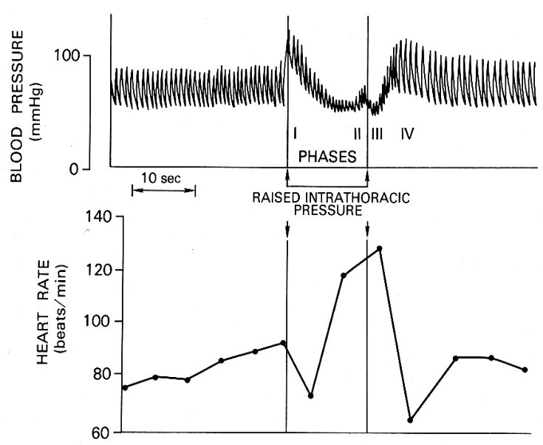
II. Valsalva Maneuver
Fig. 3

This maneuver demonstrates a complex pattern of reflex changes pertaining to the baroreceptors.
- A valsalva is expiration against a blocked airway. For example, pushing down hard on you trachea can block your airway or someone blowing into trumpet has the same effect.
- Doing this during expiration, while contracting your respiratory muscles, will raise the pressure in your pleural space (up to 60-80 mmHg). This is the pressure surrounding your heart.
- This rise in pleural pressure means that the pressure around the heart has increased relative to the rest of your body (atmosphere), as if you have raised the heart’s relative position. This is the initial rise in pressure seen.
- The rise in pleural pressure decreases venous return dramatically.
- The pulse pressure (difference between systole and diastole) is getting smaller as the Valsalva continues. This indirectly tells us that the stroke volume is getting smaller. This is due to the increased pleural pressure inhibiting the return of blood back to the heart.
- At the end, the system begins to compensate and you get a slight rise in BP (Phase II). When the Valsalva is released, you get a drop in pressure (Phase III), and then there is the final compensation (Phase IV)

What is happening in terns of the baroreceptors?
- The rise in arterial pressure relative to atmosphere is read as hypertension in the carotid sinus. This leads to an increased vagal response and decreased sympathetic activity. This causes the initial drop in HR.
- Then the pressure begins to fall and the baroreceptors overshoot their response. When they stop the vagal output, this rapidly increases the HR and increases sympathetic activity.
- Increasing sympathetic activity changes the capacitance of the vasculature. You are converting unstressed volume to stressed volume to improve flow back to the heart
- Now we release the Valsalva. There is an immediate fall in pressure in the heart, which causes more sympathetic activity. This results in an overshoot in pressure.
- When the baroreceptors detect this overshoot in BP, it increases vagal and inhibits sympathetic activity to return the BP to its original level

  - Vagal discharge after the release of Valsalva can be combined with carotid massage to break an arrhythmia.

III. Local Regulation of Peripheral Flow
There are 3 major mechanisms that regulate peripheral flow.

Metabolic Response
- This is the major method of regulation
- The exact signal for regulation is unknown. Several possibilities include: O₂, CO₂, K⁺, osmolality, adenosine, prostaglandins, etc. It is most likely that all of the above are involved.

Reactive Hyperemia:
- Consider the situation where you occlude your arteries by a cuff.
- During occlusion, the flow will drop.
- When released it does not return immediately to its original flow. It will overshoot first and then decrease.
Why is there an overshoot?
- It is thought that during occlusion, there is a build up of metabolites. When you release, these metabolites cause the dilation of smooth vascular muscle and allow of a transient increase in flow.
- As you occlude for a longer period of time, more metabolites build up and you get a larger increase in flow

Active Hyperemia:
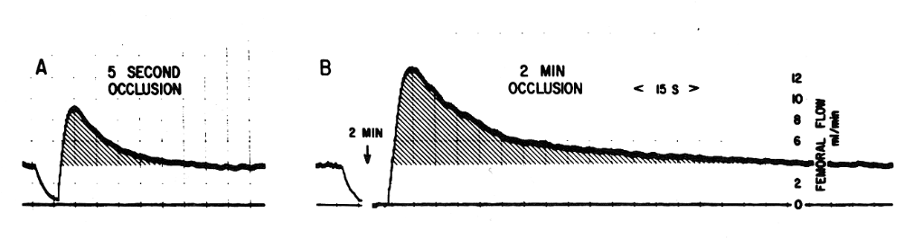
- This is the increase in flow during exercise, but it is only one of the many factors that regulate flow during exercise.
Fig. 4

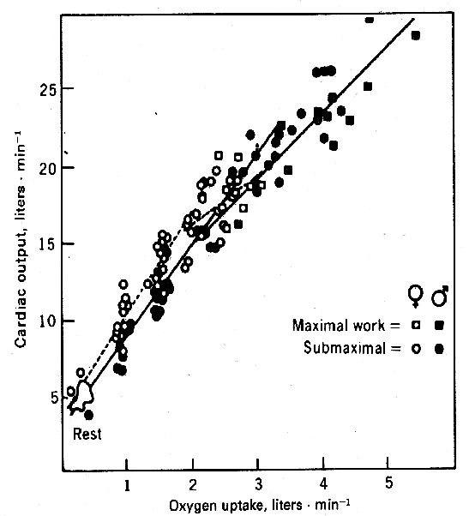
Cardiac Output and VO₂
Fig. 5
- Under normal conditions there is a linear relationship between CO and VO2. As you increase the O2 demand, the flow increases.
- This indicated that flow increases with metabolic needs.
- If you occlude an artery, the O2 demand increases when you release the area. To meet the nutrient demands, the flow to this area will increase, due to the build up of metabolites during occlusion.
- Because of this linear relationship, if you know a person’s oxygen consumption you can predict their CO within 5% of its actual value (given that they have normal hemoglobin levels).

Myogenic Response
- This is the response of the vascular smooth muscles to stretch
- When stretched, they tend to contract. This is a way of autoregulating flow.
- For example, an increase in pressure stretches the smooth muscles and triggers their contraction. This increases resistance, resulting in the maintenance of flow

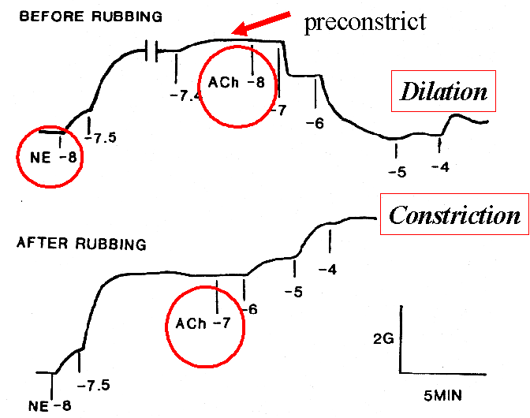
Flow-Mediated Dilation

Experiment:
- Rabbit aortic vessels were being used to study vascular tone and the effects of cholinergic receptors on the effects of tone.
- They would add their drugs to a strip of muscle and look at it constrict and dilate.
- When vasoconstricted with NE, the ring gained tension. When a cholinergic drug (ACh) was added, it was found that with increasing concentrations it would constrict. These results were reproducible for years and used in many publications.
Fig 6.
- A new technician however found that when he added the ACh, the vessel would dilate.
Why is it dilating after always constricting?
- The new technician had cut the vessel into cross-sections, keeping the ring intact.
- Constriction had occurred because previously the vessels had always been cut length-wise, disrupting the ring.
- They found that by cutting the vessel this way, traumatized the endothelium and removed it. By cutting it the technician’s way the endothelium stayed intact.
- Fig 6. demonstrates these results. By rubbing and removing the endothelium, the vessel constricted due to ACh. But by not rubbing and leaving the endothelium intact, the vessel dilated in response to ACh

Endothelial Dependent Dilation
- The above experiment illustrates endothelial dependent dilation. It was clear that ACh was acting on the endothelium to cause the release of a dilating substance.
- It was finally discovered that nitric oxide (NO) was being released by the endothelium. NO is made by endothelial nitric oxide synthase. ACh leads to the increase in Ca²⁺ in the cell, which activates this synthase.
Fig. 6

- NO freely diffuses to the smooth muscle where it acts on soluble guanylate cyclase (sGC), involved in muscle relaxation and arterial dilation.

IV. Regulation of Coronary Flow and Autoregulation
Fig. 6

Regulation of Coronary Flow
- Like in the rest of the body, there is a linear relationship between coronary flow and O₂ consumption We can look at the determinants of cardiac oxygen demand and supply:
- Demands: heart rate, contractility, wall tension
- Supply: coronary flow (arterial pressure, outflow pressure, resistance), O₂ content of blood

- Heart rate is a major energy demand.
- Just by knowing the HR we can get a good idea of myocardial energy demands and flow requirements
- An exercise test is used in standard clinical situations to assess the state of coronary arteries
  - As the heart rate increases, the coronary flow must increase due to the increase in O₂ demand. So heart rate reflects the state of the coronary arteries, because they must be in good shape to increase flow enough to support an increased HR.

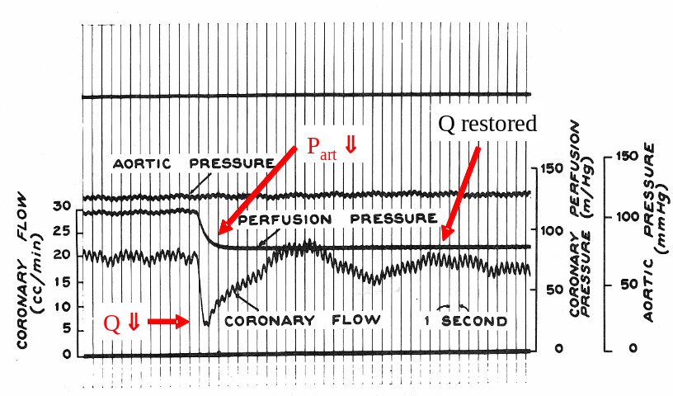
Autoregulation
Fig. 7
- Autoregulation occurs strongly in the heart and in the brain.
- For example, if we keep the blood pressure in the whole body constant (baroreceptors are inactive) and changed the flow in a coronary vessel, what happens?
- The perfusion pressure in the coronary artery drops.
- The flow initially drops, but rises again. Since our baroreceptors have been inactivated, it must be due to a local factor. This most likely occurs through a myogenic or metabolic metabolism.

Note: Dr. Madger skipped a few slides at the end of this lecture. Don’t worry; we won’t be tested on this material!

